A

**Understanding the car_crash DataMart**

## Sample Data

This Appendix will be used to help the reader better understand the schema of the DataMart used in the sample queries

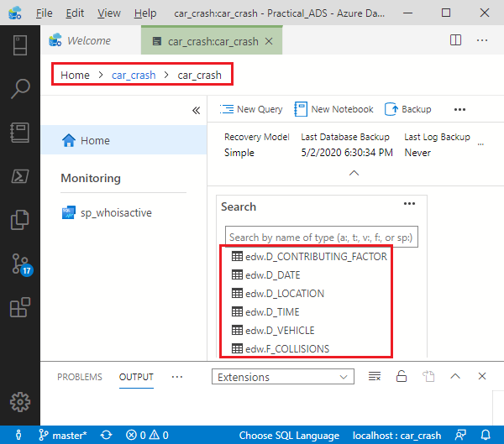

Figure A-?. ‘edw’ Tables Comprising the car_crash DataMart

…

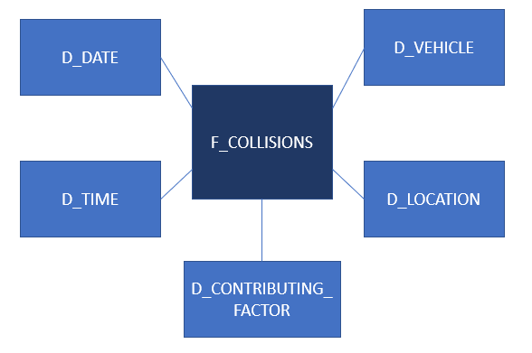

Figure A-?. Star Schema for car_crash DataMart